Introduction to Probability Test | Name:
K/U |  | T/I |  | C |  | A

Knowledge and Understanding
Short Answer
- A coin is flipped, a die rolled, and a card drawn from a regular deck. Determine the probability that heads are flipped, a five is rolled, and a face card is drawn.
When a coin is flipped, there are two outcomes. (HEAD, TAIL)
P(HEAD) = $\frac{1}{2}$
When a die is rolled, there are six outcomes. (1,2,3,4,5,6)
P (5) = $\frac{1}{6}$
There are 12 Face cards in a total of 52 cards.
P(FACE) = $\frac{12}{52}= \frac{3}{13}$
$∴$ P(HEAD), P (5) and P(FACE) = P(HEAD)$×$P (5) $×$ P(FACE)
$$\frac{1}{2} ×\frac{1}{6}×\frac{3}{13}=\frac{1}{52}$$

- What is the probability of flipping at least three tails with four fair coins?
Four coins have 16 outcomes and we have 5 events which have at least 3 tails.
P (At least 3 tails) =$\frac{5}{16}$
- There are 18 students who are randomly assigned an order to present their projects. Determine the probability that Erin will be chosen to present first and Jason will be chosen to present second.
We will use permutation formula because the students are ordered.
^{n}$P_{r}$ = $\frac{n!}{\left(n-r\right)!}$ Where n = the total number of objects and r = objects selected.
P (Erin 1st and Jason 2nd) = $\frac{16P_{16}}{18P_{18}}= \frac{\frac{16!}{\left(16-16\right)!}}{\frac{18!}{\left(18-18\right)!}}= \frac{16!}{18!}= \frac{1}{306}$
- If two standard dice are rolled, what is the probability of a sum of 2 or a pair (doubles)?
We have a total of 36 outcomes and 6 ways of getting doubles.
P(doubles) = $\frac{6}{36}= \frac{1}{6}$
We have 1 way of getting a sum of 2
P (sum of 2) = $\frac{1}{36}$
Therefore, $\frac{1}{6 }+ \frac{1}{36}=\frac{7}{36}$
- A survey at a school asked grade 12 students if they were attending college, university or neither next year. The results can be seen in the table below.
 | College | University | Neither
Females | 27 | 49 | 15
Males | 29 | 33 | 27

Use these results to determine the probability that:
- A randomly selected student is attending university next year
P(UNIVERSITY) = $\frac{82}{180}=\frac{41}{90}$
- A randomly selected female student is not attending either college or university next year.
P(Female not attending either college or university) = $\frac{15}{91}$

- A randomly selected student who is attending college next year is male
P(Student attending college is male) = $\frac{29}{56}$
- A randomly selected male student is going to either college or university next year.
P(Male going to college or university) = $\frac{29}{89}+\frac{33}{89}=\frac{62}{89}$
Application
1. A mother and father have three children. Assuming there is a 50:50 chance of a boy or girl:
a. Construct a probability tree for this scenario.
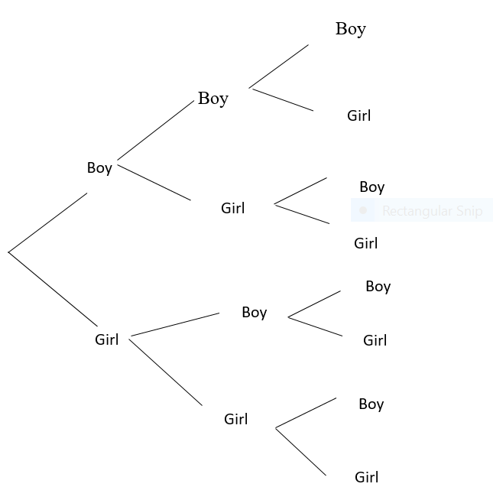
b. What is the probability that at least 2 of the children are girls?
P(At least 2 are girls) = $\frac{4}{8}=\frac{1}{2}$
2. A survey given to 35 students showed that 12 of them have part-time jobs, 16 of them belong to a school team and 4 of them have a job and belong to a school team. If a student is randomly selected, what is the probability that the student:
a. has a part-time job or belongs to a school team?
Let A = Part time job, A’ = not in part time job
B = School team, B’ = not in school team
P (A or B) = P(A)P(B)-P (A and B)
= $\frac{12}{32}+ \frac{16}{32}- \frac{4}{32}=\frac{3}{4}$
b. does not have a part-time job and does not belong to a school team?
P(A’) and P(B’) = P(A’) $×$ P(B’)
= $(1-\frac{3}{8})×(1-\frac{1}{2})$
= $\frac{5}{8} ×\frac{1}{2 }=\frac{5}{16}$
c. belongs to a school team given that they have a part-time job?
P(B/A) = $\frac{P(A and B)}{P(A)}$
=$\frac{\frac{1}{8}}{\frac{3}{8}}=\frac{1}{3}$

d. has a part-time job given that they do not belong to a school team?
P(A/B’) = $\frac{P(A and B')}{P(B')}$
= $\frac{\frac{3}{8} ×\frac{1}{2}}{\frac{1}{2}}=\frac{3}{8}$
3. A drawer contains 6 brown socks, 7 grey socks and 8 black socks.
a. If Paul draws two socks from the drawer determine the probability that they are both brown if:
i. the first sock is replaced.
P(Brown) = $\frac{6}{21} ×\frac{6}{21}=\frac{4}{41}$
ii. the first sock is not replaced.
P(Brown) = $\frac{6}{21} ×\frac{5}{20}=\frac{1}{14}$
b. Draw a probability tree for this scenario and use this to determine the probability that Paul ends up with a match assuming he does not replace the first sock.
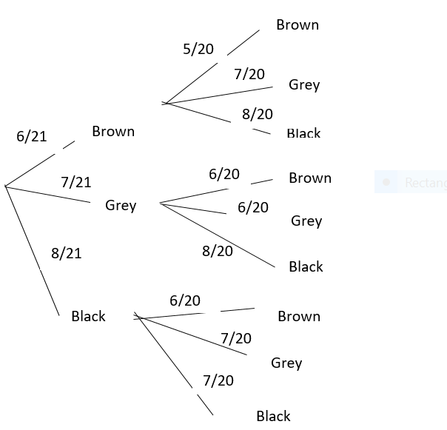
Thinking/Inquiry (pick 2)
1. Thalia estimates that the odds in favour of her passing physics are 3:1 and the odds against her passing English are 1:4. Assume that {passing English} and {passing Physics} are independent events.
Let A = Odds in favor of passing Physics, A’ against her passing physics
B = Odds against her passing English, B’ in favor of her passing English
P (A) =$\frac{3}{4}$ P (A’) = $\frac{1}{4}$
P (B) = $\frac{1}{5}$ P(B’) = $\frac{4}{5}$
a. What is the probability that Thalia will pass both subjects?
P (A) and P (B’) = $\frac{3}{4}×\frac{4}{5}=\frac{3}{5}$
b. What is the probability that Thalia will pass only one of these two subjects?
P (A or B’) = P (A) + P (B’) - P (A $∩$ B)
= $\frac{3}{4}+\frac{4}{5}-\frac{3}{5}=\frac{19}{20}$
c. What are the odds against Thalia failing both subjects?
P (A) and P (B’) = $\frac{3}{4}×\frac{4}{5}=\frac{3}{5}$
2. Darren is playing a game that requires him to pay $1 to roll two dice. If he rolls on a 6 or an 8, he wins $3. If he rolls anything else, he loses. Would you advise him to play this game? Show your calculations and explain your reasoning.
Dice | Outcome | Probability
6 or 8 | 3 | 5/18
Other | 0 | 13/18
Expected value is $\left(3×\frac{5}{18}\right)+\left(0×\frac{13}{18}\right)-1=\frac{-1}{6}$
This means that every time you play, on average you lose 16.67 cents.
I would advise him not to play the game.

